Fraction Game
Description:
These games can be played by two, three or four children. The purpose of these games is to help students see parts of the whole and equivalent fractions.

Objectives:
To visualize equivalent fractions with fraction pieces. To make a whole from parts that require regrouping.

Resources/Materials:
Rectangular fraction pieces.

Activities/Procedures:
Each student makes a set of five fraction strips that look like the following diagrams. Card which is 12" x 4" works best.

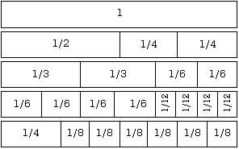

Students are to cut along the lines and write their initials on the back of each piece. Provide envelopes so students can have their own set of fraction pieces. [Different coloured card for each pupil within a group]

The fraction pieces are the materials for the following games:

Game 1:
Each player empties all the pieces from their kit into a common pile. Each player draws until all pieces have been drawn. Each player begins putting the pieces back together into the same shape as the long strip. (a) The first student who assembles three whole long strips is considered the winner. Each player draws until all pieces have been drawn.
(b) The player who has the most equivalent pieces to 1/2 wins. A time limit is helpful in this activity.

Game 2: Each player empties all the pieces from their kit into a common pile. Each player draws two pieces until each student has 10. The remaining pieces are set aside during this game.
(a) The first player who first fits all of the parts he or she has drawn into a long strip or strips equivalent to one, wins. If a player needs a piece he or she may ask for one from other players; however, equivalent parts must be exchanged. For example, if player No. 1 needs 1/8 to win and has 1/4, he or she may say, "I need eighths, I will trade one 1/4 for two 1/8's." The player must have 1 entire unit in an exact way.
(b) They could work together as a team to support each others attempts to form an entire unit.

Evaluation:
This is an activity in which students can check each other through their long strips formed in the game and the oral communication answers.

